**Govt. Brijindra College, Faridkot**

**Feedback Form -2021-22 (Teachers)**

**55 responses**

**Type of Appointment**

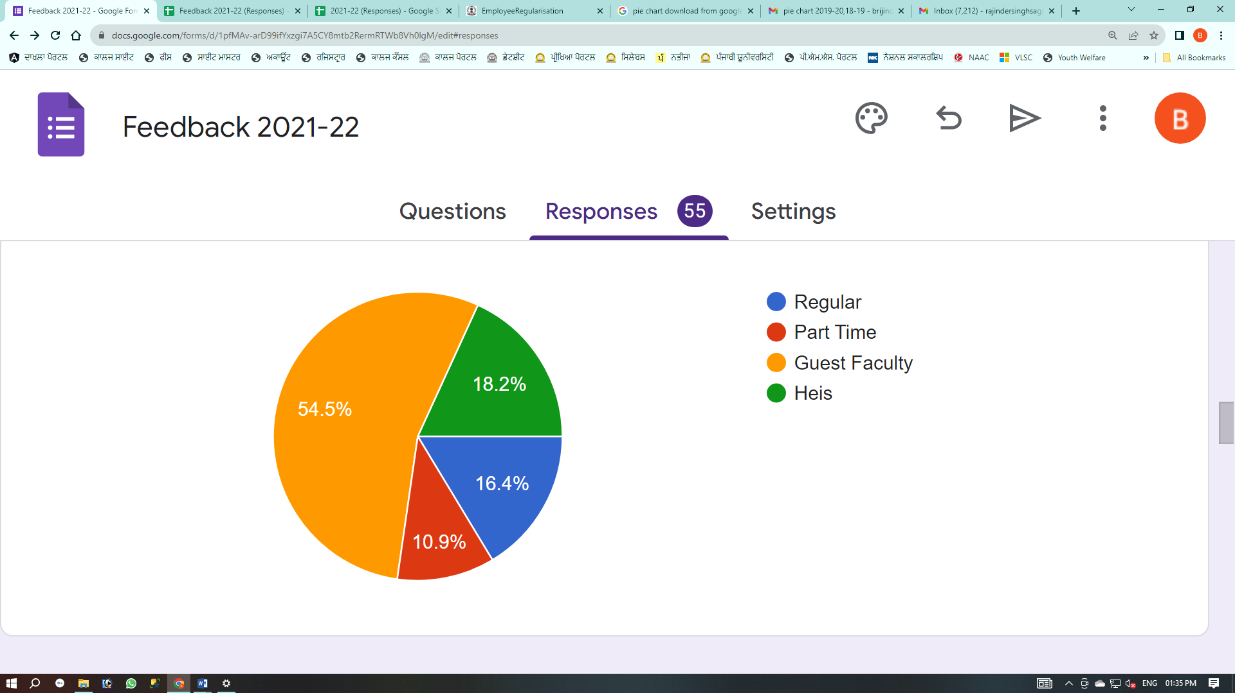

**Q.1:     Rate your experience about the teaching learning process.**

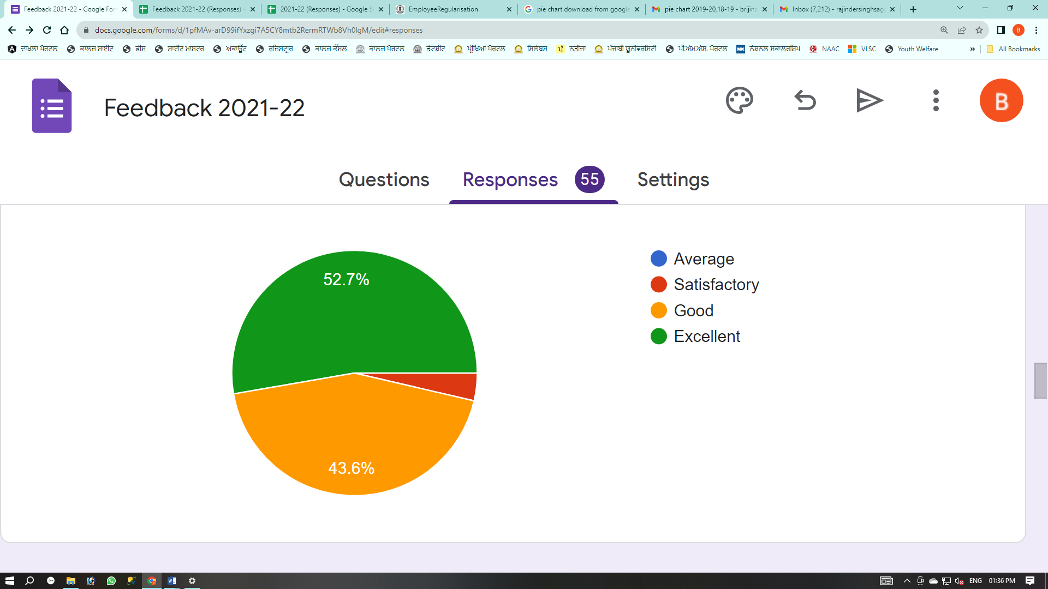

**Q.2:     Rate the teaching learning atmosphere in the college.**

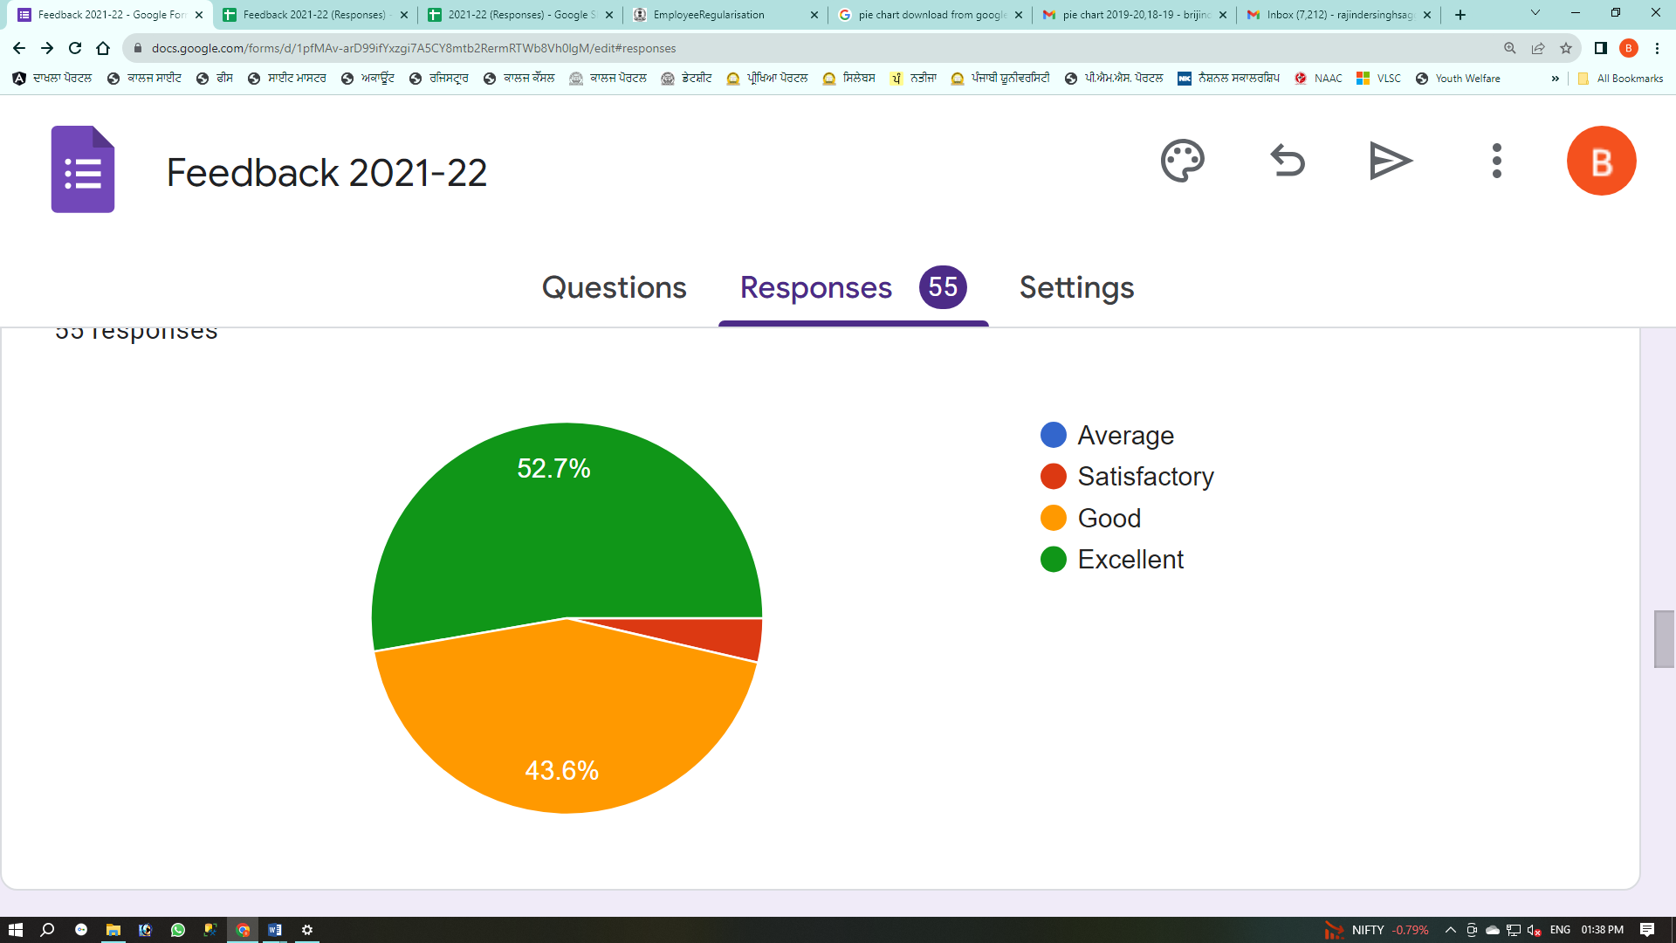

**Q.3:     Rate the college campus as environment friendly campus.**

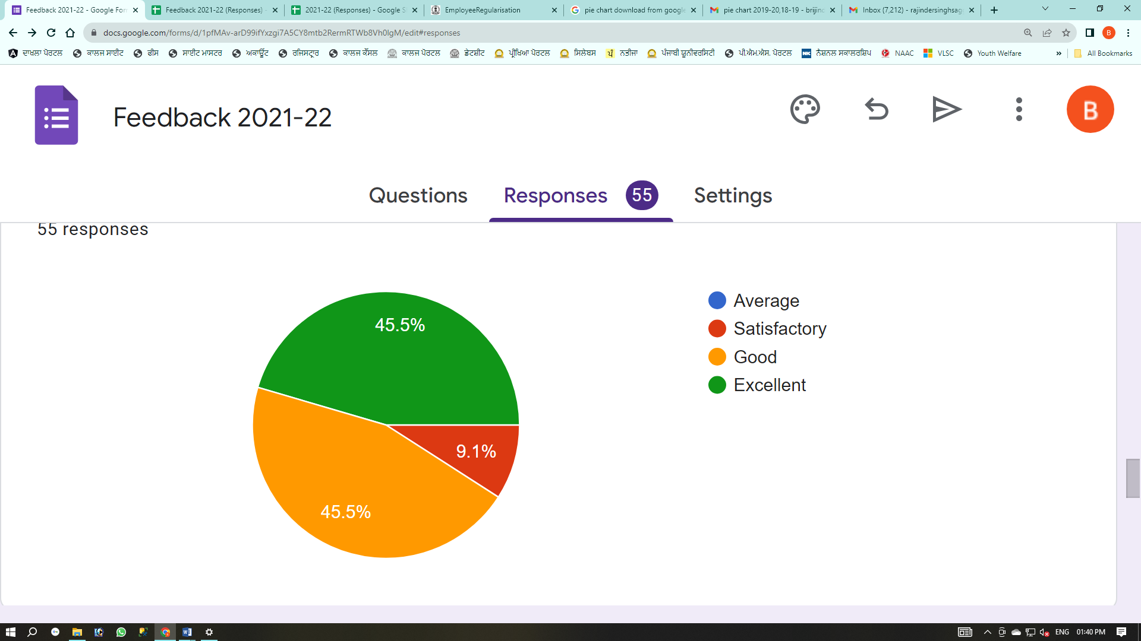

**Q.4:     Rate the measures taken by the college in development of ethics and moral values in the students.**

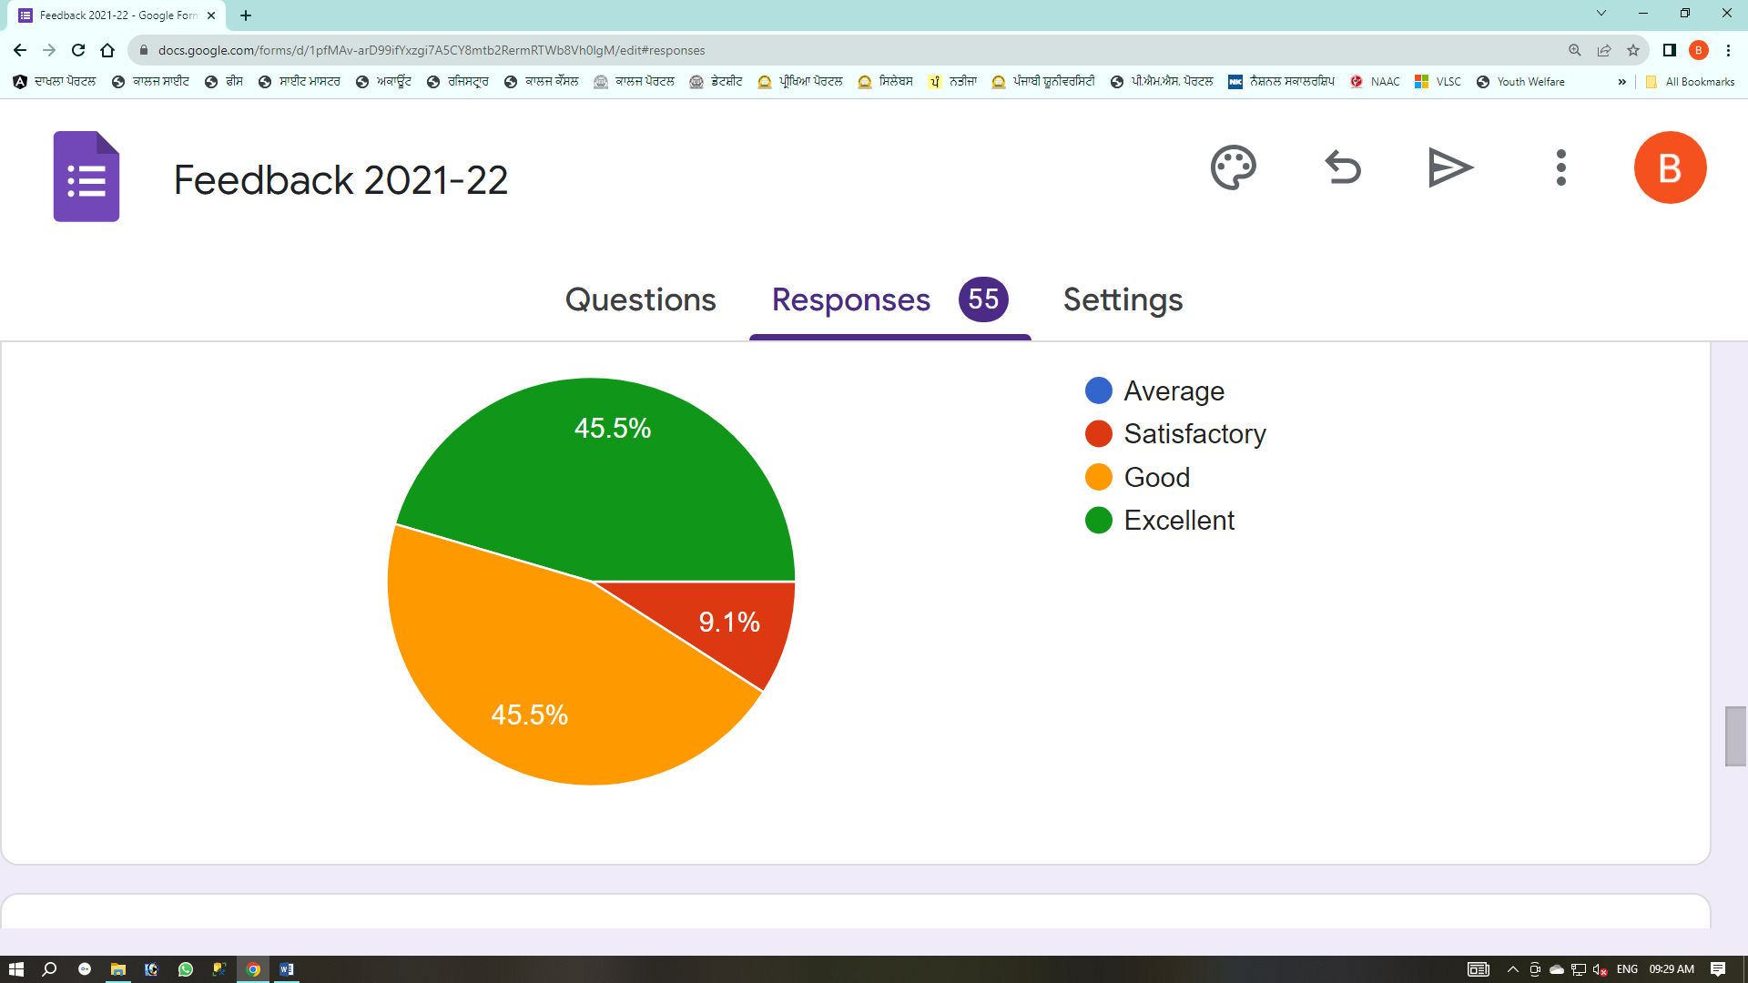

**Q.5:     Rate the attendance of students in the classes.**

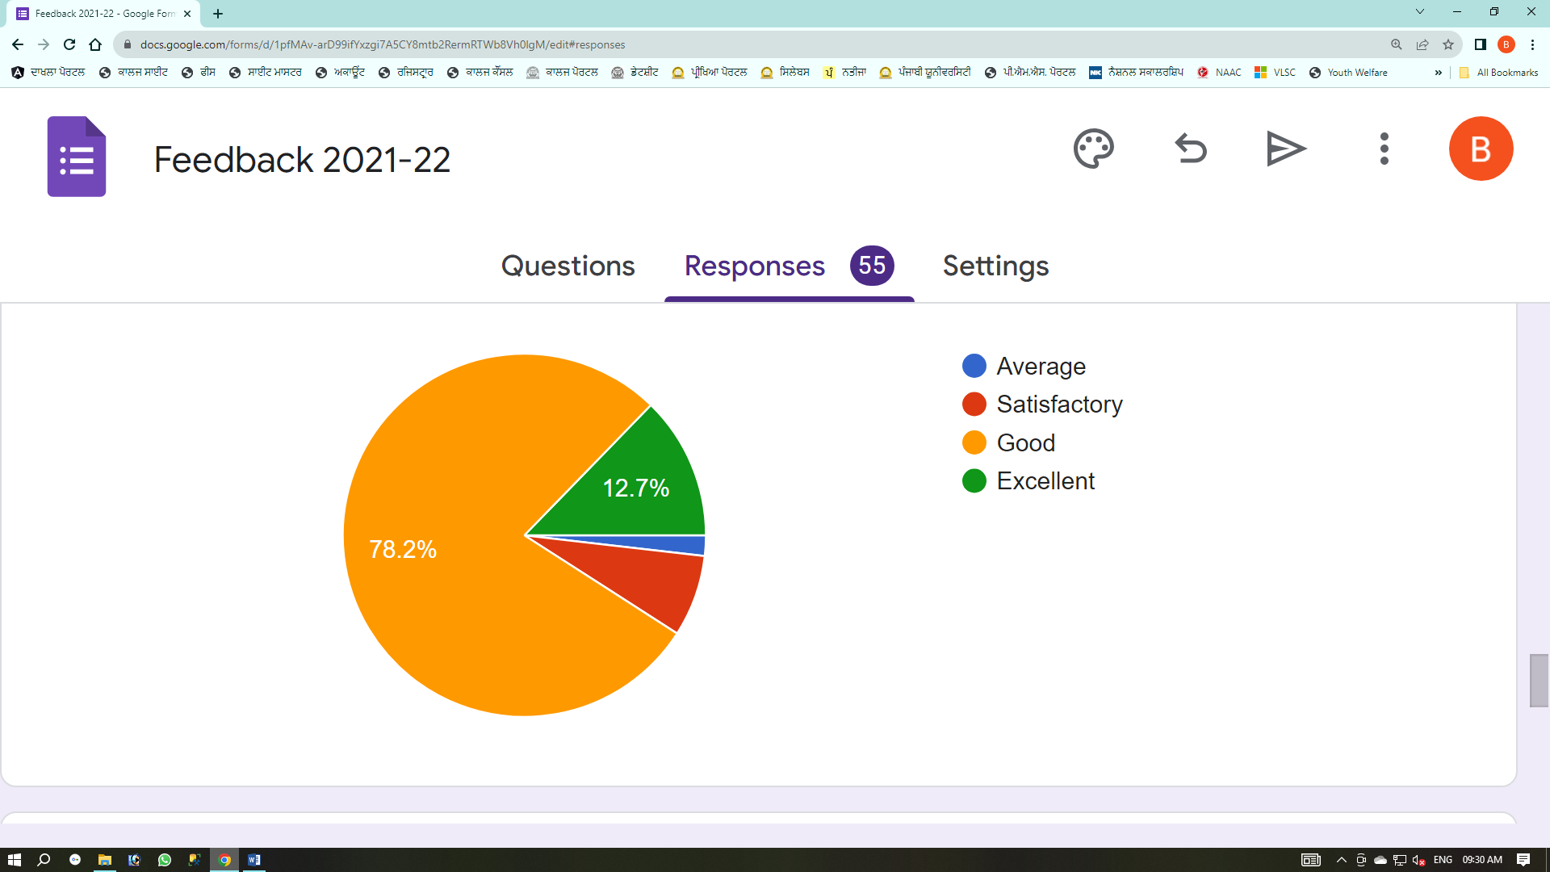

**Q.6:     The participation of the teacher in research and innovation process.**

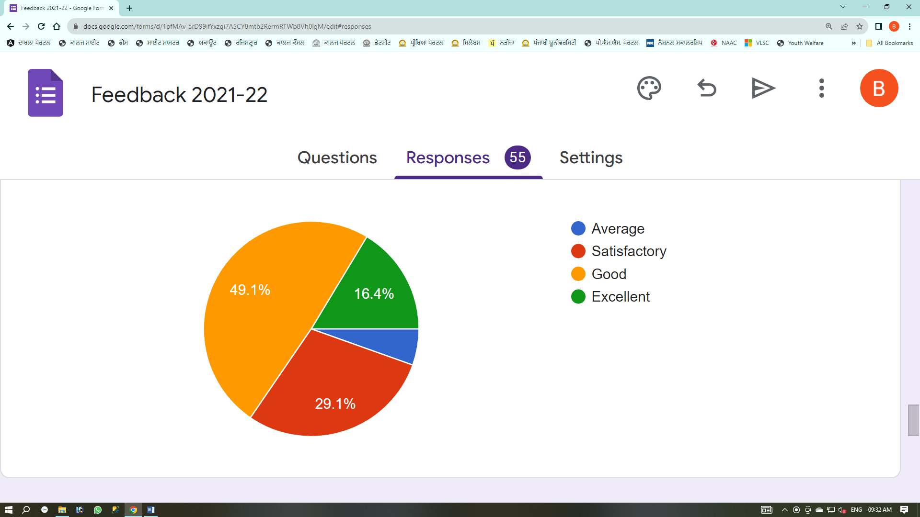

**Q.7:     Rate the basic infrastructure facilities in the college.**

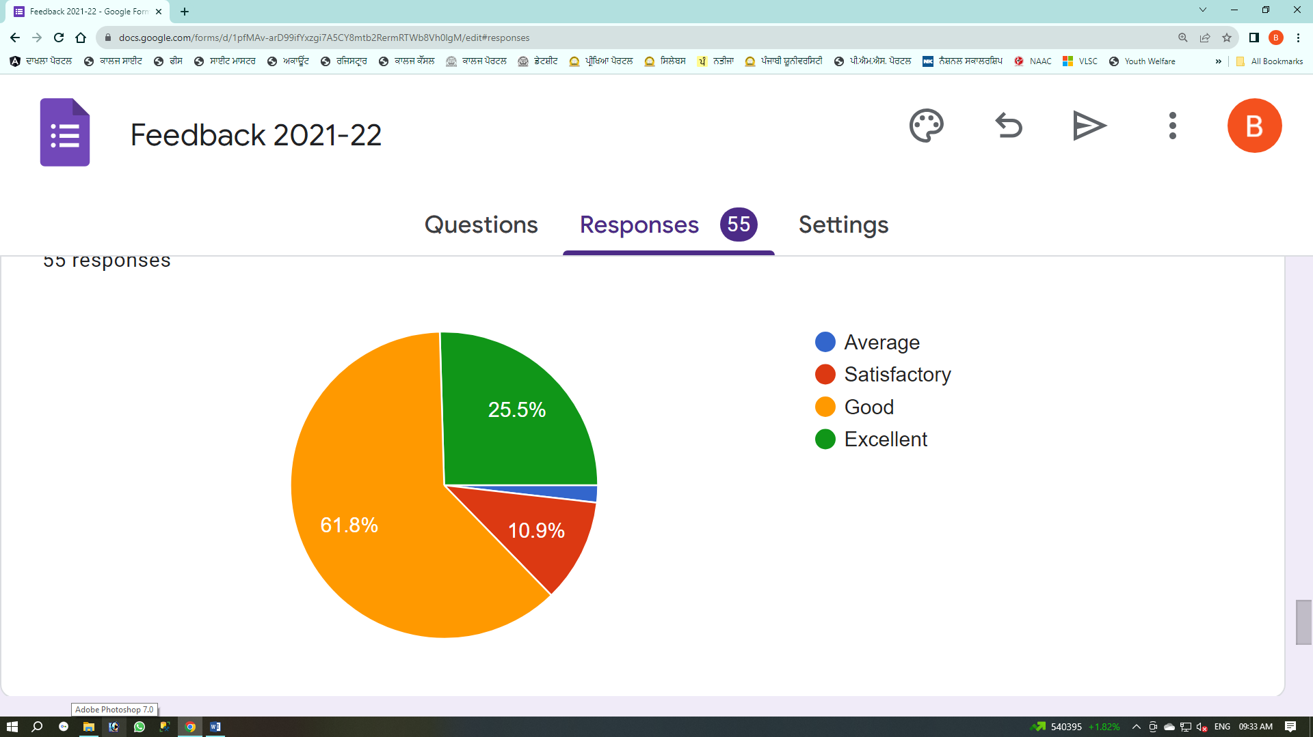

**Q.8:     Rate the sports facility in the college.**

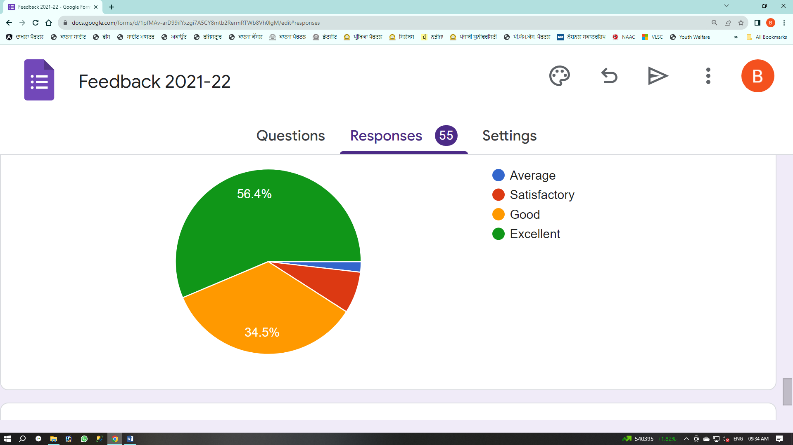

**Q.9:     Rate the teachers' welfare schemes available for the staff.**

